

Print to PDF



Course Syllabus

This is the official syllabus and course outline for Physics 111.

# PHYS 111 (3) Introductory Physics for the Physical Sciences I

The UBCO calendar description of this course is:

Introduction to mechanics primarily for students majoring in the physical sciences (e.g. physics, chemistry, mathematics, computer science, geology, physical geography) or engineering. Particle kinematics and dynamics, work and energy, momentum, gravitation, rigid body motion, fluid statics and dynamics with applications to the physical sciences. Credit will be granted for only one of PHYS 111 and PHYS 112.

Students with Physics 12 may apply for a tutorial exemption. [3-3-1]

*Prerequisite*: One of MATH 12, PREC 12, MATH 125, MATH 126 and PHYS 11. Physics 12 is strongly recommended.

*Corequisite*: MATH 100.

# Is this syllabus a contract?

Rather than interpreting this syllabus as a legal document that serves as a contract between the instructor and the students, I prefer to view the syllabus as a *living document*. Dr. John Warmer describes this best in his article, “A syllabus is not a contract”:

… this syllabus is not a contract, it is a living document which reflects the experiences, emotions, philosophies, and goals I bring to a particular course.

and also:

A syllabus as a plan is a lot like an itinerary before a trip. There’s some definite highlights we need to hit, but if something that seems cool and worth doing crops up unexpectedly, we need to seize that opportunity in the moment. If something really bad happens (the equivalent of a norovirus breakout on a cruise ship) we may need to abandon something previously scheduled entirely.

Interestingly, it is worth noting that a recent review of legal precedents suggests that syllabi are not considered contracts by the courts [1].

Having an adaptive and responsive syllabus is important to me as an instructor because it allows me to be more flexible with what/how/when you learn, and respond to your feedback in a meaningful way. I invite you to be co-contributors to this syllabus, and use the tools provided to add your own annotations, questions, and suggestions on making this syllabus work for you.



Please note that I have your best interests in mind, and it is highly unlikely that I will ever change a syllabus in a way that negatively affects the class, or even individual students. If you believe a syllabus change is affecting you negatively, please do not hesitate to reach out to me, or submit your feedback anonymously here.

Important

# Changes to the syllabus since the start of Term

Any major changes to the syllabus (this page) will be documented here as well as the date the change was made.

Change

Date Summary Rationale

Sept. 4,

2020

Updated textbook price to remove tax; fix class time, clarify vol1/vol2 Tax is applied depending on where you’re purchasing from

so is variable(?)

Sept. 5,

2020

Added UBC statement on “Online learning for international students” and added an extra clarification about the textbook

UBC has requested the language to be added for students taking this course outside Canada.

# About this course

Name Description

Course Physics 111

Term 2020/21 Winter Term 1

Canvas Course Link to Canvas course (requires CWL authentication)

Mastering Physics code moosvi87376 (This is our course code and you will need it when you first log on to Mastering Physics) Pre-requisites One of MATH 12, PREC 12, MATH 125, MATH 126 and PHYS 11. (Physics 12 is strongly recommended.)

Co-requisites Math 100

Additional Course Fees Total $115.50 + tax CAD Lectures Online Thursdays at 12:00

Tutorial You must(^) register for a tutorial section. Laboratory You must register for a laboratory section. URL https://firas.moosvi.com/courses/physics111

Instructor Firas Moosvi

Office Hours Zoom

Email Contact via Piazza



(^) Students with Physics 12 wanting a tutorial exemption should just register for XM2 - there is no application necessary.

Tip

# A message from your instructor

See this video message showing you how to navigate the course website.



# Contact the Teaching Team

|  |  |  |  |
| --- | --- | --- | --- |
| Michael Kudla | TA | Piazza | TBD |
| Stephen Collins | TA | Piazza | TBD |
| Graham Bovett | TA | Piazza | TBD |
| Ramie Ali-Adeeb | TA | Piazza | TBD |
| Graham Bovett | TA | Piazza | TBD |
| Gurbir Amrit | TA | Piazza | TBD |
| Graham Bovett | TA | Piazza | TBD |

Team Member Role Pronounce as Contact Office Hour Dr. Firas Moosvi (he/his/him) Instructor Fur-az Moose-vee Piazza TBD

# How will I be evaluated in this course?

The grading scheme for this course is here:

Item Weight Due date(s)

Learning Logs 10% (10 x 1%) Fridays at 18:00

Homework Assignments 20% (10 x 2%) Wednesdays at 18:00

Labs 20% (8 x 2.5%) Variable

Tests (& Bonus Tests) 30% (5 x 6%) Thursday at 18:00 to Saturday at 18:00 Final Exam 20% In the exam period

There will be 5 tests in this course in an (approximately) bi-weekly schedule. For each of the tests, there will be a bonus test exactly one week later and the better score of the Test-Bonus Test pair will be taken.



All deadlines in this course have an automatic 48 hour grace period after the due dates listed above. Any submissions submitted past the grace period will not be graded.

Attention

## Are there other requirements I need to know about to pass the course?

Yes. To pass this course, you must do all of the following:

Achieve a minimum of 50% on the labs (10.0 / 20) with no more than 3 missed labs Achieve a minimum of 50% on the tests and final exam (25.0 / 50)

Achieve a minimum of 50% on the whole course grade (50.0 / 100)

# Course Learning Outcomes (AKA what will I learn in this course?)



The full course schedule is available here: Course Schedule

Tip

What do I need to purchase for this course?

The following are required items for this course, and their costs (in $CAD) are:

eTextbook ($115.50 + tax) OR physical textbook (variable)

Access to online homework system ($0; included with new purchases) Lab Manual ($0)

Being very conscious of the high tuition and technology costs, I have made efforts to minimize the additional cost of taking this course. Below is a justification of each required item and why I think you need it to succeed in this course.



Do not procrastinate buying access to the online homework system! You will need it right away.

Warning

## Textbook



The required textbook for this course is: Physics for Scientists and Engineers, 4e by Randall D. Knight.

Tip

It is required because you need a reference text for this course, as well as practice problems, and a homework system. The Mastering Physics homework system comes bundled with this textbook.



tl;dr version: Purchase the eText + Mastering Physics access code for $115.50 + tax. This is all you will need.

Attention

The cost for a new e-Text (with MasteringPhysics code) is listed above. With the e-Text, there is no option to purchase separate volumes and you will get access to the full textbook. If you choose to purchase a physical copy from the UBCO Bookstore, there is also no choice - you will need to purchase both volumes ($150 + tax). Volume 1 contains all of the material required for PHYS 111 and will be lighter and more portable. If you purchase the full physical textbook, it will include Volume 2 which will (tentatively) be used in the second part of Introductory Physics for the Physical Sciences (PHYS 121) in term 2.

Either an e-Text or a physical textbook will work as long as you have the Mastering Physics access code to get access to the homework system. New textbooks from the UBCO bookstore have it included. If you purchase your textbook from elsewhere, or have a used textbook you’ll need to purchase it separately. Update: there is now option to purchase just the Mastering Physics access for 50.50*ƒromthelin+aboue*. *Tobeclear*, *theUBCOBoo+storehasthreeoptions* : 1)*eTextrithMasteringPhysicsaccesscode*(115.50 + tax),

1. Physical textbook with Mastering Physics access code (150 + *tax*), 3)*MasteringPhysicsaccesscodeonly*(50.50 + tax). Most students will

choose choose Option 1.



The UBCO bookstore has warned me there may be shipping delays due to COVID-19 if you choose to get a physical textbook. If you’re ordering it online or through the bookstore, I encourage you to call or email to confirm there is stock, and that the shipping times (if applicable) are reasonable before placing the order.

Warning

## Online homework system



The required online homework system for this course is: Mastering Physics

Tip

It is required and is a companion product to our textbook. There is considerable research (here and here) that suggests distributed practice is more helpful for long term retention and overall learning. Furthermore with online Mastering Physics interface, your textbook, homework assignments, and tests are all on Mastering Physics. Mastering Physics also has some integrated study modules that can help you test yourself and take more effective notes.

## Lab Manual



The required lab manual for this course is: Available on Canvas, free of charge.

Tip

In the past, this lab manual had to be purchased from the UBC Bookstore. This year, because the labs are all online, a digital version of the lab manual is available to you on Canvas free of charge.

# How will this course be taught ?

This course will be a Flipped Classroom; this is a technique pioneered largely by Dr. Eric Mazur and extended by others. Briefly, it requires students to watch videos and engage with the assigned reading prior to the classroom meeting (knowledge transfer). During the class meeting, the instructor guides students through clicker questions, worksheet problems, and other activities to help the students make sense of the material (sense-making). See Fig. 1 for a mental model of how learning works [2].

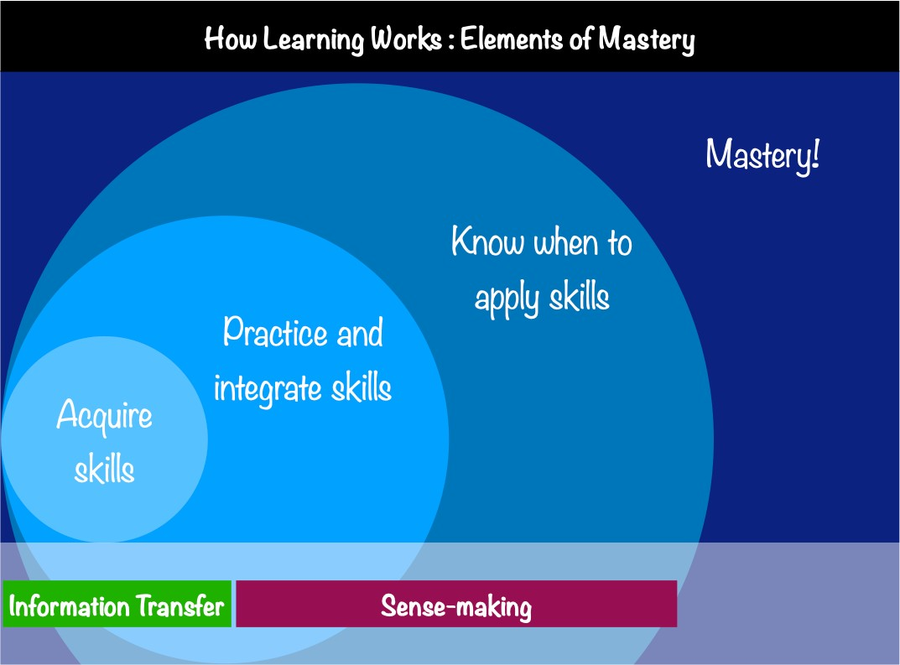

Fig. 1 To develop mastery in a concept, students must first acquire the necessary skills, then practice integrating them, and finally know when to apply what they have learned. This figure was adapted from Figure 4.1 of the book “How Learning Works”. The terms “knowledge transfer” and “sense-making” applied in this context is generally attributed to Dr. Eric Mazur.

## What does this mean in practical terms?

Fig. 2 shows a handy table to help guide you and organize your learning in this course:

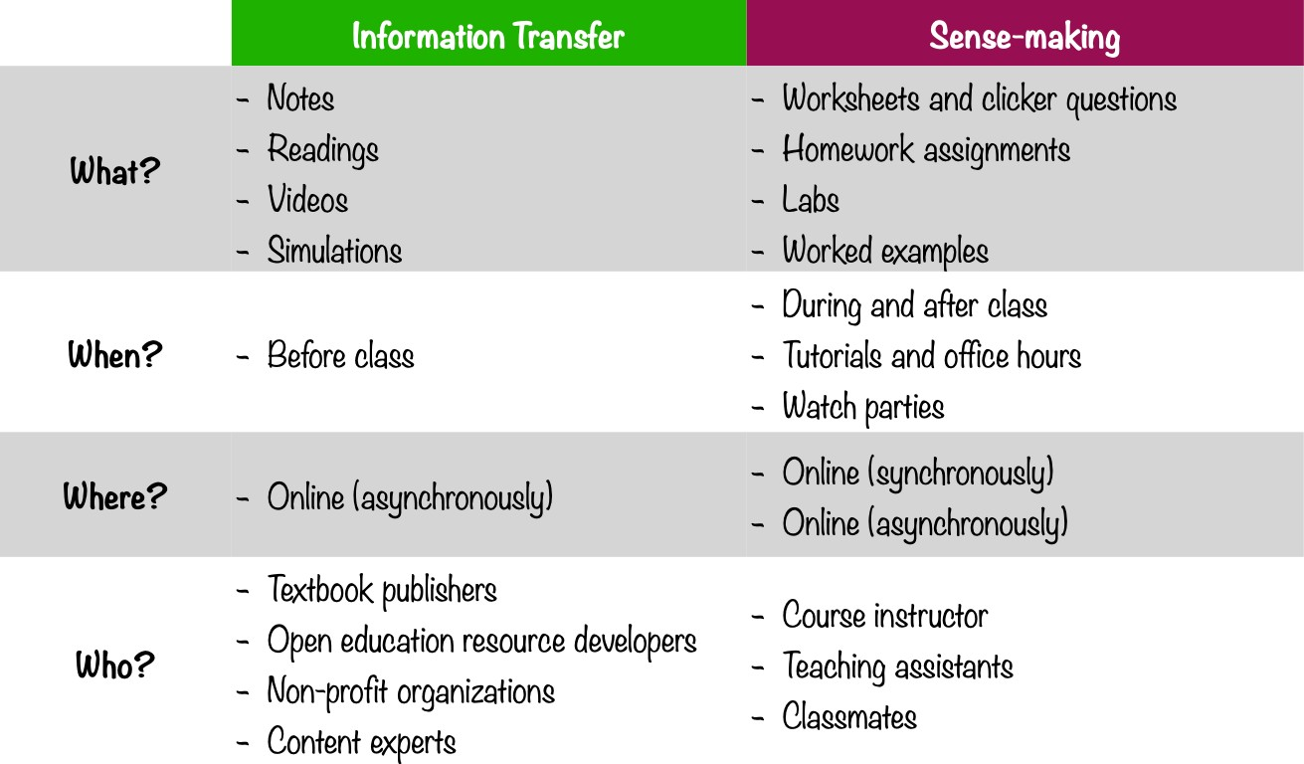

Fig. 2 This table describes how I think each course activity should be classified between knowledge transfer and sense-making.

## Want to know more about my teaching philosophy ?

For a detailed description of my teaching philosophy and values (including a list of references and citations), you can read it here. Here are the key principles I intend to apply in this class:

* 1. Student learning is vastly improved through active learning.
  2. Effective teaching is inclusive teaching.
  3. Learning technologies must be leveraged to scale instructor effort across multiple classes.
  4. Exploring the connections between different disciplines is an extremely powerful motivator.
  5. Teaching is three parts preparation, two parts classroom management, and one part execution.

# Course Communication

For lectures, labs, tutorials, and office hours we will be using Zoom. For official course communication, we will be using Canvas and Piazza.

For unofficial chat, community building, sharing of tiktoks, cat videos, and general conversation we will (optionally) be using a Discord server.



Please note signing up for the Discord server is completely optional! You will not miss anything course-related if you choose not to get on the Discord.

Warning

## Sign up for a (free) Zoom account

Instructions coming soon…

## Sign up for a (free) Piazza account [Required]

This term we will be using Piazza for class discussion. The system is highly catered to getting you help fast and efficiently from classmates, the TA, and myself. Rather than emailing questions to the teaching staff, I encourage you to post your questions on Piazza.

*The Piazza tool is stored on servers outside Canada. When you access this site by clicking on the link through Canvas, you are being transferred to these servers. In order to protect your identity, UBC obfuscates your user ID before it is sent to the site. However, Piazza does require you to create an account on their servers. While Piazza adheres to strict U.S. privacy regulations (FERPA), UBC cannot guarantee security of your private details on servers outside of Canada. Please exercise caution whenever using personal information. You may wish to use a pseudonym to protect your privacy if you have concerns.*

Sign up for our class Piazza.

## Sign up for the Discord Server [Optional]

You can download Discord for free on desktop here, or through the Google Play store or Apple App Store on mobile and tablets. Invitation to join the unofficial UBCO first year science Discord Server!

Here is a Beginner’s Guide to Discord and if you prefer watching a video:



Again, please note signing up for the Discord server is completely optional, and is an experiment we are trying to help maintain human interactions during online learning.

# What should I think about if I’m considering withdrawing from the course?

First of all, I’m sorry you’re having trouble and are considering withdrawing from the course! This is no problem, and I will not be personally offended or upset you need to do this, I encourage you to do what you feel is right for you and your situation. Below is some information that might be helpful for you in making the decision.

Withdrawal type Effect on Transcript Tuition refund Before September 21, 2020 11:59 PDT None 100% refund Before November 13, 2020 11:59 PDT W on transcript See UBCO Calendar After 11:59 PDT November 13, 2020 ^ W on transcript See UBCO Calendar

^ Note: Withdrawal after this date cannot happen without approval from the Faculty (Email: fos.students.ubco@ubc.ca).

There are factors other than money and your transcript to consider as well, including your mental health, graduation requirements/timelines, eligibility for student loans, bursaries, scholarships etc. I advise you to read the full list of considerations here and conslt with an Academic Advisor or your Program Advisor if you have additional questions.

# How do I do well in this course?

For full details, please see the page How to do well in this course.

To whet your appetite on what you’ll read there, here are some guidelines on preparing yourselves for this course:

1. Learning is a contact sport.
2. Memorizing is not learning.
3. Understanding is learning and understanding should be your goal.
4. We’ll do lots of tests.

And some ingredients for your success:

1. Plan.
2. Prepare.
3. Engage.
4. Practice.
5. Collaborate.
6. Do not be fooled by familiarity of the material.
7. Math.

## … but I’ve never been good at physics or math!

That’s okay! You’re still more than welcome in this course. I will do everything I can (within reason) to still make the course accessible to you. This course is designed with your success in mind. There are multiple opportunities for you to learn from your mistakes and improve your grades in nearly every aspect of the course. In my opinion, the best learning happens when folks are given the opportunity to make mistakes so they get over their fear of trying something! At the beginning of the term, we will all do a Math Diagnostic (not for marks) to check if you have the required math background for this course. If you do not, I have some supplemental material for you to catch up. My expectation is that you’ll complete the exercises and review the supplemental material in the first couple of weeks.

To summarize, if you’ve never been “good” at physics or math, come into the course with a healthy attitude, a desire to work for your success, and I have no doubt you will be successful in this course. If you ever want to talk about the course, or have any feedback you want to give me, do not hesitate to reach out to me!

## … but I don’t even like physics or math!

Believe it or not, I have no expectation that every student that takes my course will have an undying passion for the subject. Some of you may be forced to take this course by your programs, faculties, career interests, etc… Sometimes we all have to take courses that we think we don’t like, or enjoy.

That’s fine! No judgement from me, you are more than welcome in this course. I just ask that you not make any snap judgements about the class, the material, the instructor (me), or the teaching team. Whatever your motivations are for taking this course, give us a chance, maybe you don’t HAVE TO be miserable taking this course! You might even enjoy the feeling of community and camaraderie that develops over the course of the semester :-).

I hope you’re not miserable, if you do feel miserable, come talk to me - maybe I can help you see the light at the end of tunnel?

# What type of information will I collect about you in this course?

Having taught DSCI 541: Privacy, Ethics, and Security in the UBC Master of Data Science in the past, I am very aware of the surveillance culture that has permeated our society and heralded the End of Privacy as we know it. That being said, as an instructor, I care tremendously about your learning and the course-related data that is collected about you is extremely valuable. Broadly speaking, this relatively new field is called Learning Analytics. Learning Analytics involves the collection and analysis of data about learners for the express purpose of improving their learning by optimizing teaching and learning practices.

In this course, we will be using the following required learning technologies (privacy policies linked):

Canvas Piazza Sli.do

Mastering Physics

All tools used in the course will be used in a FIPPA-compliant manner, with your privacy top of mind. New tools may be added to the course as the need arises, and I will update this section with the appropriate information and make an announcement if a new tool is added midway through a course.

All of the tools above log data about your activity that can be used to improve the quality of teaching and learning. In this course, I intend to use this information to:

view overall class progress (in aggregate),

track your personal progress in order to provide you with personalized feedback, track participation in discussion forums

improve the course and your learning, explore students actions in the course, provide you feedback on your progress.

Unfortunately, at the moment it is not possible to opt-out of the data collection process, but if you like, you may opt-out of the process where *I use the data to give you personalized feedback*. To opt-out, please complete this form at any point in the course. You may opt-out with my full support, I respect your decision and applaud you for your netizenship!

## Optional Tools

There are some learning tools that I would like to experiment with this year, and I will not require you to sign up for these (but you are free to do so to explore):

Hypothes.is



Desmos

… others may be added as needed.

# What should I do if I need accommodations to be successful in this course?

Accommodations are intended to remove barriers experienced by individuals with disabilities. As a matter of principle, UBC is committed to promoting human rights, equity and diversity, and it also has a legal duty under the BC Human Rights Code to make its goods and services available in a manner that does not discriminate. Policy 73 (Accommodation for Students with Disabilities) sets out principles and processes governing the accommodation of students with disabilities.

All accommodations for this course are handled through the Disability Resource Centre and I encourage you to contact them to book an appointment. For a more detailed guide, the Accommodations page has a list of steps you should take for this course.

## What if I miss labs, tests, or the exam due to an illness, health, or other personal situation?

Students who, because of unforeseen events, are absent during the term and are unable to complete tests or other graded work, should normally discuss with their instructors how they can make up for missed work. If ill health is an issue, students are encouraged to seek attention from a health professional. Campus Health and Counselling will normally provide documentation only to students who have been seen previously at these offices for treatment or counselling specific to conditions associated with their academic difficulties. Students who feel that requests for consideration have not been dealt with fairly by their instructors may take their concerns first to the Head of the Department, and if not resolved, to the Office of the Dean. Further information can be found at the UBCO Calendar.



If you miss a course component due to an illness, health, or other personal situation, please reach out to me as soon as you are comfortable, and I’ll work with you to get you back on track.

Tip

## What if I have dependents that rely on me for care and unpredictable emergencies may arise?

Let’s talk, send me a private message and we can discuss it. I do not necessarily need to know all the personal details, just a high-level summary of your situation and what you think an ideal solution would be.

I’m sure we will come to some agreement, generally the earlier you let me know of any special circumstances or accommodation, the more I’ll be able to do for you!

## What if I have to miss a deadline because of a wedding, birthday, funeral, religious holiday, or personal event ?

No problem! There’s not even any need to tell me, or ask for permission to miss deadlines. The course is designed to give you maximum flexibility:

Every deadline has a 48-hour grace period that is automatically applied. There is no late penalty if you use the grace period

You can use the grace period an unlimited amount of time in the course (though if it happens every week and for every assignment, I might check in with you and gently encourage you not to leave things to the last minute)

If you miss a deadline by more than the grace period, the general course policy is that you will get 0 on it. In some cases, I reserve the right to grant an extension, or provide an alternate assignment.

# Compassion

As I’m sure you’re aware, *there is a global pandemic* happening right now and we could all use some extra compassion and humanity. If you’re going through something that is affecting you (course or otherwise), you are always welcome to come and talk to me about it. If I am not able to help you myself, then I can probably direct you to the right person or resource. If you need extra help, or extra time to deal with something you’re going through, just ask. You will *never* owe me an explanation about your physical health, mental health, or those of your family members, friends, etc… I will believe you, and I will trust you. I will not judge you, nor think any less of you. I will do everything in my power to work out something that is both reasonable and fair. This, I promise!

# How do I go through this course ethically and with integrity?

I want to be proud of your work in this course, and I want YOU to be proud of yourself as well! That cannot happen if you make unethical decisions, including (but not limited) to cheating or plagiarism. According to the scientific literature, the most common reasons students cheat are:

Fear of failure and life consequences

Peer pressure, including an inability to say no to help others cheat

Perceived societal acceptance of cheating (Lance Armstrong, Barry Bonds, Enron, Wall Street & the The Big Short) Desire for success without the time/desire to put in the work needed

Strict deadlines and due-dates

Requirement from instructors to memorize facts, figures, equations, etc… High-stakes exams with no recompense for “having a bad day”

Peers cheating with no consequences or penalties

Unclear expectations on what constitutes academic dishonesty Inadequate support from instructor and teaching team

Though I sympathize with students and the stresses of your busy lives - in my opinion, there is no good reason to cheat. I have tried extremely hard to make this course focused on learning rather than grading, and where grading is needed, to have policies that are as student-friendly as possible. In particular, I hope (and expect) that the following features of the course should eliminate your temptation to cheat or plagiarize:

48 hour grace-period on all homework and lab due dates and deadlines.

Long testing window (48 hours) so you can start the tests whenever you’re comfortable.

Weekly learning logs, homework and reading reflections to make you think about your learning (metacognition). Timed tests have generous time limits (allowable time is 1.25x the estimated time).

Each test has a “bonus test” available one week later; for each test, we will take the better score of the pair. No high-stakes exams (the single largest assessment item is the final exam at 20%).

All course assessments are completely open book and open notes.

Plenty of TA and instructor office hours and several outside of normal business hours.

Class website that outlines exactly what you should do when to help you manage your time.

Tonnes of supplemental materials including other instructional videos in case you want a different perspective. Weekly prompt to accept the integrity pledge to keep you accountable.

A true willingness from the instructor (me) to help you learn and succeed in this course!

A more detailed description of academic integrity, including the University’s policies and procedures, may be found in the Academic Calendar.

## My personal plea

With these features, and many other little things, I sincerely hope that you will consider completing this course with maximum integrity so that you never have to feel guilty, ashamed, or disappointed in yourself and your actions!

To make it even easier for you to decide what isn’t allowed, below is a list of things that I definitely consider to be academic dishonesty:

Asking others for their work in the course (whether question by question, or all at once) Sending others your work in the course

Doing tests collaboratively (tests must be done by yourself and alone) Sending others your test questions and/or answers

Sharing any course material onto Chegg, Course Hero, Slader, or other similar sites

Searching for solutions to course material on Chegg, Course Hero, Slader, or other similar sites

Blindly googling the question in hopes of finding someone who had a similar question and then copying their answer Note, googling to find resources to understand specific concepts or general ideas is highly encouraged!

Having a tutor/friend/nemesis complete and submit your work for you

Copying and pasting code, equations, text explanations, prose, etc… without attribution

Manipulating the learning platforms we use to reverse engineer the randomization algorithms, hacking the timer functionality, or other similar technical malfeasance.

## UBCO’s statement on Academic Integrity

The academic enterprise is founded on honesty, civility, and integrity. As members of this enterprise, all students are expected to know, understand, and follow the codes of conduct regarding academic integrity. At the most basic level, this means submitting only original work done by you and acknowledging all sources of information or ideas and attributing them to others as required. This also means you should not cheat, copy, or mislead others about what is your work. Violations of academic integrity (i.e., misconduct) lead to the breakdown of the academic enterprise, and therefore serious consequences arise and harsh sanctions are imposed. For example, incidences of plagiarism or cheating may result in a mark of zero on the assignment or exam and more serious consequences may apply if the matter is referred to the President’s Advisory Committee on Student Discipline. Careful records are kept in order to monitor and prevent recurrences.

# UBC Policies

UBC provides resources to support student learning and to maintain healthy lifestyles but recognizes that sometimes crises arise and so there are additional resources to access including those for survivors of sexual violence. UBC values respect for the person and ideas of all members of the academic community. Harassment and discrimination are not tolerated nor is suppression of academic freedom. UBC provides appropriate accommodation for students with disabilities and for religious and cultural observances. UBC values academic honesty and students are expected to acknowledge the ideas generated by others and to uphold the highest academic standards in all of their actions. Details of the policies and how to access support are available here.

## Online learning for international students

During this pandemic, the shift to online learning has greatly altered teaching and studying at UBC, including changes to health and safety considerations. Keep in mind that some UBC courses might cover topics that are censored or considered illegal by non-Canadian governments. This may include, but is not limited to, human rights, representative government, defamation, obscenity, gender or sexuality, and historical or current geopolitical controversies. If you are a student living abroad, you will be subject to the laws of your local jurisdiction, and your local authorities might limit your access to course material or take punitive action against you. UBC is strongly committed to academic freedom, but has no control over foreign authorities (please visit this calendar page for an articulation of the values of the University conveyed in the Senate Statement on Academic Freedom). Thus, we recognize that students will have legitimate reason to exercise caution in studying certain subjects. If you have concerns regarding your personal situation, consider postponing taking a course with manifest risks, until you are back on campus or reach out to your academic advisor to find substitute courses. For further information and support, please visit: https://academic.ubc.ca/support-resources/freedom-expression/.

## Copyright Disclaimer

Diagrams and figures included in lecture presentations adhere to Copyright Guidelines for UBC Faculty, Staff and Students and UBC Fair Dealing Requirements for Faculty and Staff. Some of these figures and images are subject to copyright and will not be posted to Canvas. All material uploaded to Canvas that contain diagrams and figures are used with permission of the publisher; are in the public domain; are licensed by Creative Commons; meet the permitted terms of use of UBC’s library license agreements for electronic items; and/or adhere to the UBC Fair Dealing Requirements for

Faculty and Staff. Access to the Canvas course site is limited to students currently registered in this course. Under no circumstance are students permitted to provide any other person with means to access this material. Anyone violating these restrictions may be subject to legal action.

Permission to electronically record any course materials must be granted by the instructor. Distribution of this material to a third party is forbidden.

## Grievances and Complaints Procedures

A student who has a complaint related to this course should follow the procedures summarized below:

The student should attempt to resolve the matter with the instructor first. Students may talk first to someone other than the instructor if they do not feel, for whatever reason, that they can directly approach the instructor.

If the complaint is not resolved to the student’s satisfaction, the student should go to the departmental chair John Braun at SCI 388, 250-807- 8032 or e-mail him at [john.br](mailto:john.braun@ubc.ca)[aun@ubc.ca.](mailto:aun@ubc.ca)

## Grading Practices

Requirements to pass the course are listed above How will I be evaluated in this course?.

Faculties, departments, and schools reserve the right to scale grades in order to maintain equity among sections and conformity to University, faculty, department, or school norms. Students should therefore note that an unofficial grade given by an instructor might be changed by the faculty, department, or school. Grades are not official until they appear on a student’s academic record. If you have any questions about how academic integrity applies to this course, please consult with your professor.

## Disability Assistance

The Disability Resource Centre ensures educational equity for students with disabilities, injuries or illness. If you are disabled, have an injury or illness and require academic accommodations to meet the course objectives, visit our website for more information or contact the DRC at: [drc.questions@ubc.ca.](mailto:drc.questions@ubc.ca)

## Equity, Human Rights, Discrimination and Harassment

UBC Okanagan is a place where every student, staff and faculty member should be able to study and work in an environment that is free from human rights based discrimination and harassment. If you require assistance related to an issue of equity, discrimination or harassment, please contact the Equity Office by phone (250.807.9291) or email (equity.ubco@ubc.ca), your administrative head of unit, and/or your unit’s equity representative.

## Health & Wellness

At UBC Okanagan health services to students are provided by Health and Wellness. Nurses, physicians and counsellors provide health care and counselling related to physical health, emotional/mental health and sexual/reproductive health concerns. As well, health promotion, education and research activities are provided to the campus community. If you require assistance with your health, please contact Health and Wellness in person (UNC 337) or by email (healthwellness.okanagan@ubc.ca) for more information or to book an appointment.

## Sexual Violence Prevention and Response Office (SVPRO)

A safe and confidential place for UBC students, staff and faculty who have experienced sexual violence regardless of when or where it took place. Just want to talk? We are here to listen and help you explore your options. We can help you find a safe place to stay, explain your reporting options (UBC or police), accompany you to the hospital, or support you with academic accommodations. You have the right to choose what happens next. We support your decision, whatever you decide. Visit svpro.ok.ubc.ca or call us at 250.807.9640.

## Independent Investigations Office (IIO)

If you or someone you know has experienced sexual assault or some other form of sexual misconduct by a UBC community member and you want the Independent Investigations Office (IIO) at UBC to investigate, please contact the IIO. Investigations are conducted in a trauma informed, confidential and respectful manner in accordance with the principles of procedural fairness. You can report your experience directly to the IIO via email: [director.of.investigations@ubc.ca](mailto:director.of.investigations@ubc.ca) or by calling 604.827.2060 or online by visiting investigationsoffice.ubc.ca.

## The Hub

The Student Learning Hub (LIB 237) is your go-to resource for free math, science, writing, and language learning support. The Hub welcomes undergraduate students from all disciplines and year levels to access a range of supports that include tutoring in math, sciences, languages, and writing, as well as help with study skills and learning strategies. For more information, please visit the Hub’s website (https://students.ok.ubc.ca/student-learning-hub/) or call 250-807-9185.

## SAFEWALK

Don’t want to walk alone at night? Not too sure how to get somewhere on campus? Call Safewalk at 250.807.8076.

For more information, visit our website or download the UBC SAFE - Okanagan app.

# Attribution

The syllabus was constructed and adapted from many other templates and examples. Below is the list of resources I have used to put this syllabus together:

Physics 117 (Instructor: Dr. Simon Bates)

Psychology 417A-951 (Instructor: Dr. Catherine Rawn) Dr. Christopher Jones and this tweet

Dr. Jesse Stommell Header image

# References

[1]

Martha M Rumore. The Course Syllabus: Legal Contract or Operator’s Manual? *American Journal of Pharmaceutical Education*, 80(10):177, 2016. doi:10.5688/ajpe8010177.

[2]

Susan A. Ambrose, Michael W. Bridges, Michele DiPietro, Marsha C. Lovett, and Marie K. Norman. *How Learning Works: 7 Research-Based Principles for Smart Teaching*. Jossey-Bass, San Francisco, CA, 2010. ISBN 978-0-470-48410-4.

By Firas Moosvi

All content on this site (unless otherwise specified) is licensed under the CC BY-NC-SA 4.0 license